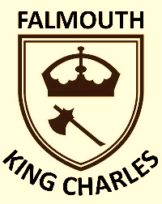
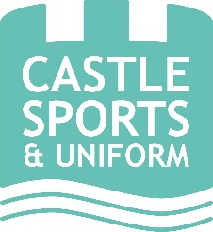
King Charles C of E School
Uniform Order Form 2026/27

ORDER DATE: |  | ORDER No. (SHOP USE ONLY):
CUSTOMER NAME:

EMAIL ADDRESS: |  | CONTACT NUMBER:
Item | Available Sizes | Size required | Unit Price | Quantity required | Amount to pay
Crew Neck Sweatshirt:  Royal Blue with school logo | Age 3-4, 5-6, 7-8, 9-10, 11-12/XXS, 13/XS |  | £13.50
Crew Neck Sweatshirt:  Royal Blue with school logo | S (Adult) |  | £16.50
Sweatshirt Cardigan:  Royal Blue with school logo | Age 3-4, 5-6, 7-8, 9-10, 11-12/XXS, 13/XS |  | £15.00
Sweatshirt Cardigan:  Royal Blue with school logo | S (Adult) |  | £17.50
Polo Shirt:  Sky Blue with school logo | Age 3-4, 5-6, 7-8, 9-10, 11-12 |  | £9.00
Polo Shirt:  Sky Blue with school logo | XS, S (Adult) |  | £11.00
PE T-Shirt:  Sky Blue with school logo | Age 3-4, 5-6, 7-8, 9-10, 11-12 |  | £6.50
PE T-Shirt:  Sky Blue with school logo | XS, S (Adult) |  | £8.00
PE Shorts:  Royal Blue | Waist 20”, 22”, 24”, 26”, 28” |  | £7.00
PE Shorts:  Royal Blue | Waist 30”, 32”, 34/36” |  | £8.50
PE Bag with school logo | One size |  | £6.00
Book Bag with school logo | One size |  | £8.50
Total amount to pay
Payment Method Card/Cash/Cheque/BACS (Please Circle) |  |  |  |  | DATE PAID:

By completing this form you are consenting to Castle Sports & Uniform Ltd holding your data in accordance with our Privacy Policy which is available at www.castlesports.co.uk.

Uniform is available exclusively through Castle Sports & Uniform Ltd at 10 Killigrew Street, Falmouth, TR11 3PG. Orders may also be placed online at www.castlesports.co.uk/king-charles-school or over the phone by calling on 01326 311805. PLEASE ORDER EARLY (by Saturday 8th August 2025 at the latest) TO ENSURE DELIVERY IN TIME FOR THE NEW SCHOOL YEAR.
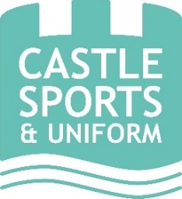
Opening times: Monday - Friday: 10.00 - 17.00
Saturday: 10.00 - 16.00
Sunday: Closed

Payment can be made by Credit/Debit Card, Cash or BACS Payments to: Castle Sports & Uniform Ltd - Sort Code: 52-41-31 Account No: 45185263

